

**KJ's Educational Institute**

**KJ COLLEGE OF ENGINEERING AND MANAGEMENT RESEARCH**

Affiliated to Savitribai Phule Pune University (SPPU), Approved by Govt. of Maharashtra, Recognized by AICTE, New Delhi.

**TE COMPUTER DEPARTMENT** YEAR 2023-24

Semester – VI

Cloud

Computing

PROJECT TITLE: Design and develop a custom Application

(Mini Project) using Salesforce Cloud

Done By:

# ROLL NO – ‘A32’

# ROLL NO – ‘A33’

# ROLL NO – ‘A46’

# 

KJ COLLEGE OF ENGINEERING AND

MANAGEMENT RESEARCH

Department of Computer Engineering



# CERTIFICATE

This is to certify that the project entitled

## “: Design and develop a custom Application

## (Mini Project) using Salesforce Cloud “

## submitted by

Anuja Atul Gudage 32(A)

Mansi Manojkumar Gudge 33(A)

Jankee Ranjeet Patil 46(A)

is a record of bonafide work carried out by them, in the partial fulfillment of the requirement for the award of Degree of Bachelor of Engineering (Computer Engineering) at

KJ COLLEGE OF ENGINEERING AND MANAGEMENT RESEARCH, Pune under the University of Pune. This work will be done during the year 2024-2023, under our guidance.

Date: / /

Guide: HOD:

Prof. Aparna s. Hambarde Dr. Nikita Kulkarni

### ABSTRACT

In today's hypercompetitive market, the efficacy of sales processes can make or break a business. This project proposes a bespoke Sales Force Cloud application aimed at redefining how sales teams operate. By leveraging the extensive capabilities of Sales Force Cloud, such as customizable workflows, automated task management, and real-time analytics, the application facilitates seamless lead management, meticulous opportunity tracking, precise quote generation, and insightful sales performance analysis. Furthermore, its integration prowess ensures harmonious data flow across platforms, fostering collaboration and coherence. With an eye on scalability, the solution is primed to adapt to evolving business needs, thereby empowering organizations to drive revenue growth, enhance customer engagement, and stay ahead of the curve in today's dynamic marketplace.

### ACKNOWLEDGEMENT

I take this opportunity to express my sincere gratitude and respect to KJ COLLEGE OF ENGINEERING AND MANAGEMENT RESEARCH, Pune for providing me a platform to pursue my studies and carry out my final year project.

I would like to thank Dr.Nikita Kulkarni, Professor and Head, Department of Computer Engineering, KJ COLLEGE OF ENGINEERING AND MANAGEMENT RESEARCH, Pune who has been a constant support and encouragement throughout this project.

I consider it a privilege and honor to express my sincere gratitude to my guide Prof. Aparna s. Hambarde, Associative professor, Department of Computer Engineering, for the valuable guidance throughout the tenure of this review.

I also extend my thanks to all the faculty of Computer Engineering who directly or indirectly encouraged me.

### INDEX

|  |  |
| --- | --- |
| **Chapter** | **Pg** |
| Abstract | i |
| Acknowledgement | ii |
| 1.Introduction | 1 |
| 2.System Requirements Specifications | 3 |
| 3.System Analysis and Design | 4 |
| 4.Implementation | 6 |
| 5.Result and Discussion | 8 |
| 6.References | 9 |

**1. INTRODUCTION**

#### • Relevance of the Project

Salesforce is a cloud computing service as a software (SaaS) company that specializes in customer relationship management (CRM). Salesforce's services allow businesses to use cloud technology to better connect with customers, partners, and potential customers. The software has become the number one for customer success and helps businesses track customer activity, market to customers, and many more services. Salesforce is a customer relationship management solution that brings companies and customers together. It is one integrated CRM platform that gives all your departments — including marketing, sales, commerce, and service — a single, shared view of every customer.2. Salesforce Lightning Experience: Salesforce Lightning Experience is simply referred to as “Lightning”. When working with Lightning Salesforce we will learn about different Salesforce lightning topics like Lightning Login, Lightning App Builder, Lightning for Outlook, Salesforce Lightning Components, Lightning Sync, and many more. Some of them are applicable in Lightning Experience only, but some others will work in both Lightning Experience and older Classic user interfaces. Lightning Sync is used to sync your user contacts and events between your email server with Salesforce.

• **Problem Statement**

Design and develop custom Applications (Mini Project) using Salesforce Cloud.

#### • Scope of the Project

Requirement Analysis:

* Conduct a comprehensive analysis of the current sales processes, pain points, and business requirements.
* Define clear objectives and goals for the custom application to address specific challenges and improve efficiency.

* Design and Development:

* 1. Design a user-friendly interface with intuitive navigation for a seamless user experience.
  2. Develop custom modules for lead management, opportunity tracking, quote generation, and sales performance analysis.
  3. Implement customization features to tailor the application according to unique business needs.

* Deployment and Rollout:

1. Plan and execute a phased deployment strategy to minimize disruption to business operations.
2. Monitor the deployment process and provide ongoing support to address any issues or concerns.
3. Collaborate with stakeholders to gather feedback and make necessary refinements.

#### 2. SYSTEM REQUIREMENTS SPECIFICATION

* Objective:

To create a custom application on the Salesforce Lightning platform.

* Software / Hardware Requirements:

OS - Windows / Ubuntu, Google Chrome.

**Salesforce Integration Cloud** provides a single view of customer data for large businesses and enterprises. This cloud helps users connect large amounts of data spread across the various cloud platforms. It is built on the MuleSoft integration platform, which [Salesforce acquired in 2018.](https://www.techtarget.com/searchcustomerexperience/infographic/Salesforce-acquisitions-of-2019-are-vendors-biggest-yet)

The main features of the Integration Cloud include the following:

* provides the Lightning Flow feature, which enables the creation of personalized customer experience across all units including sales, service and marketing;
* enables customer service reps to transform service interactions into crossselling and [upselling opportunities,](https://www.techtarget.com/searchcustomerexperience/feature/Advanced-upselling-tactics-technologies-expand-bottom-line) without ever leaving their console through the Lightning app builder feature;
* provides easy integration with third-party apps to optimize business and development processes; and
* helps with smart decisions and data optimization as data is pulled from all sources.

#### 

#### 3.SYSTEM ANALYSIS AND DESIGN

**3.1 System Architecture of Proposed System:**

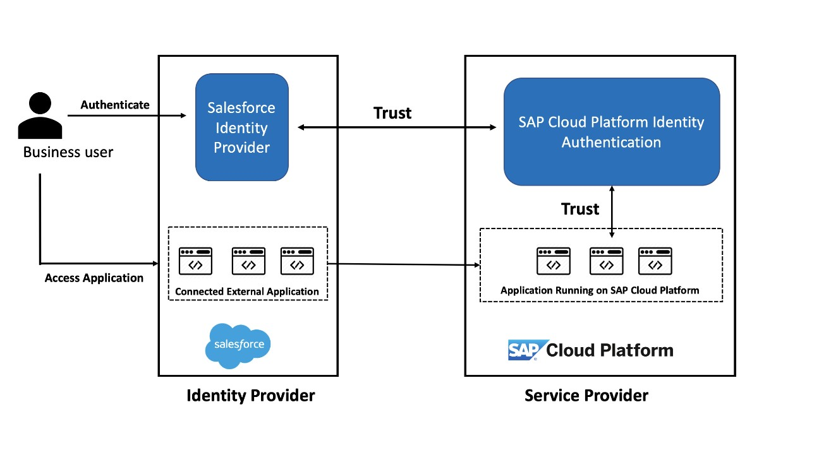

#### 

#### 4.IMPLEMENTATION

Step 1: Log into Salesforce Developer account.

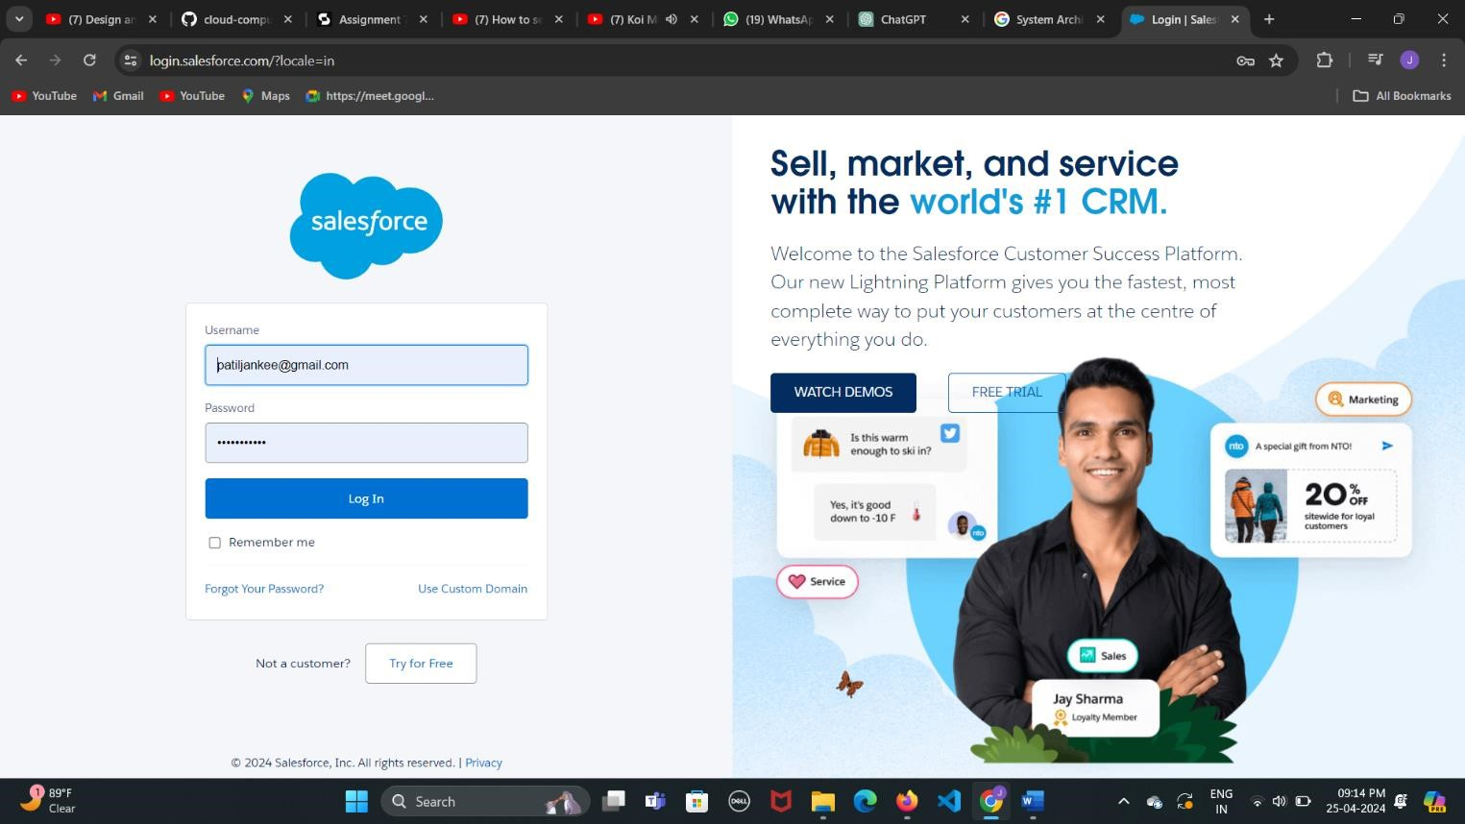

Step 2: Open the Salesforce Lightning platform and click on Object Manager => Create => Custom Object

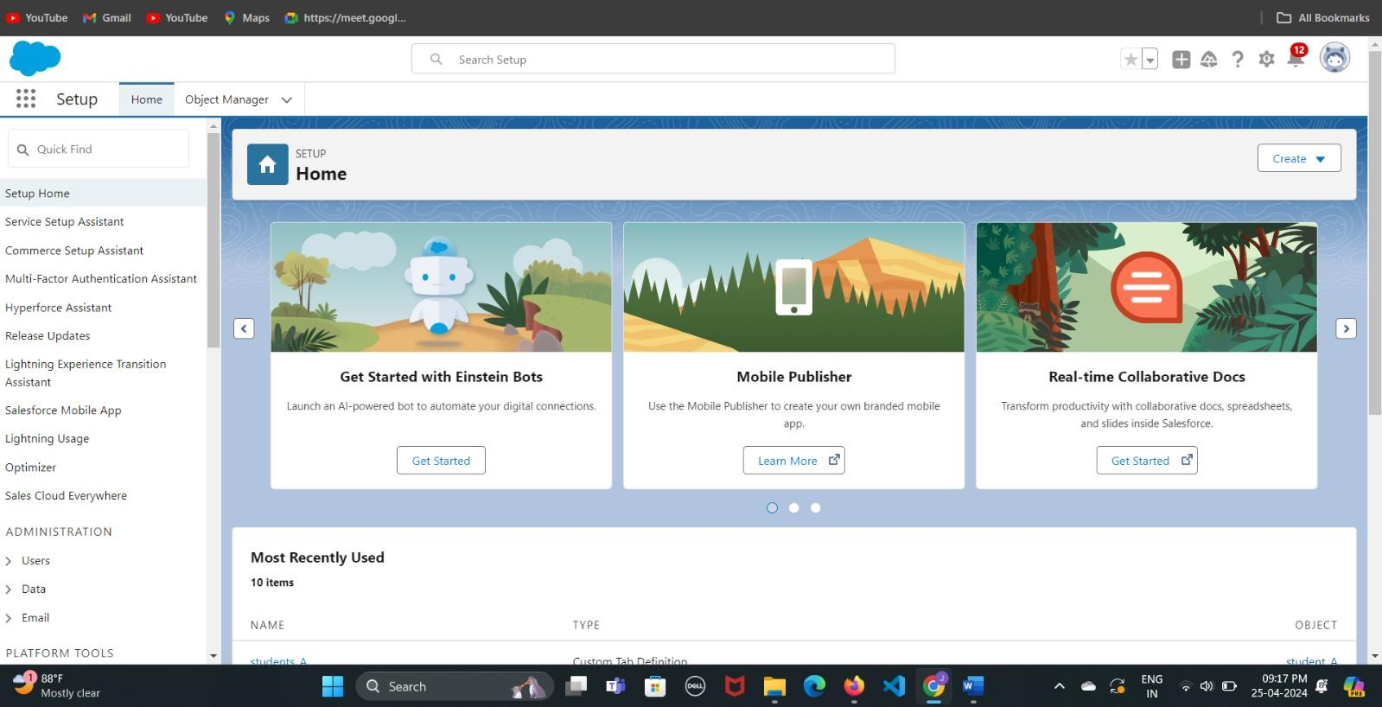

Step 3: Fill in the required fields and under Optional Features, select Allow Reports and Allow Activities. Click Save.

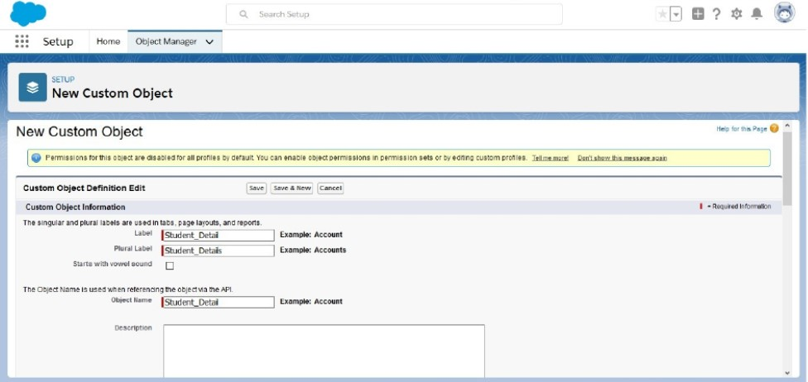

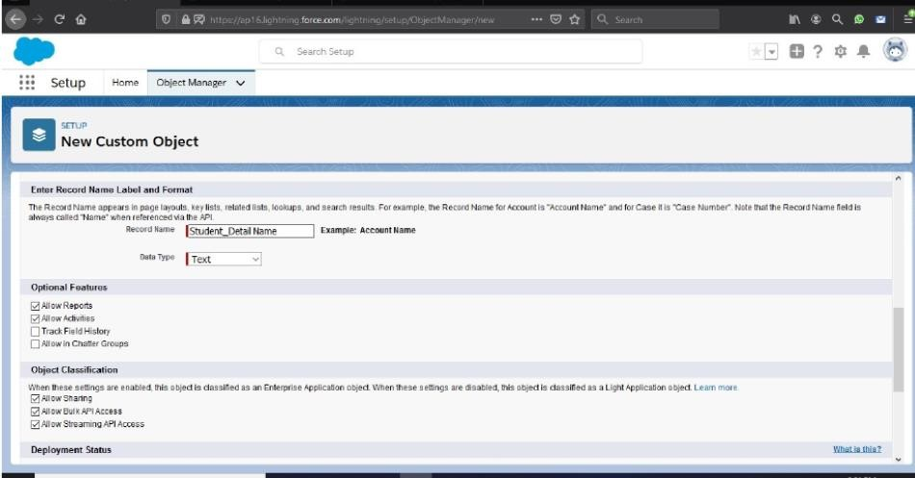

Step 4: Now, Click on Fields & Relations => New.

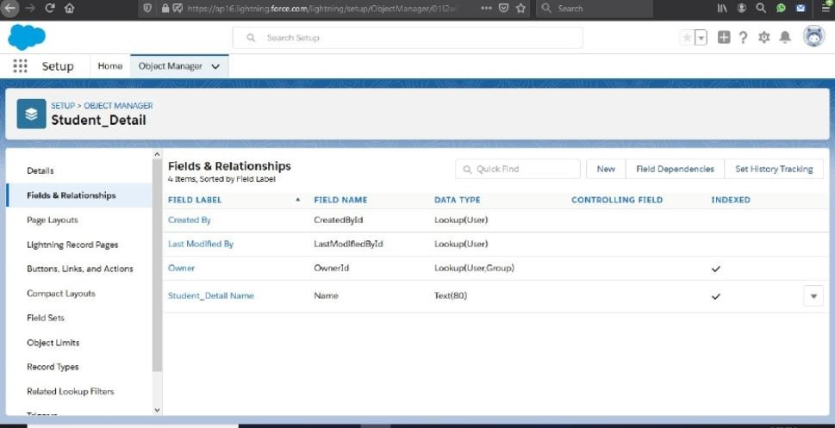

Step 5: Then select option “Text” and click Next-> Next -> Save.

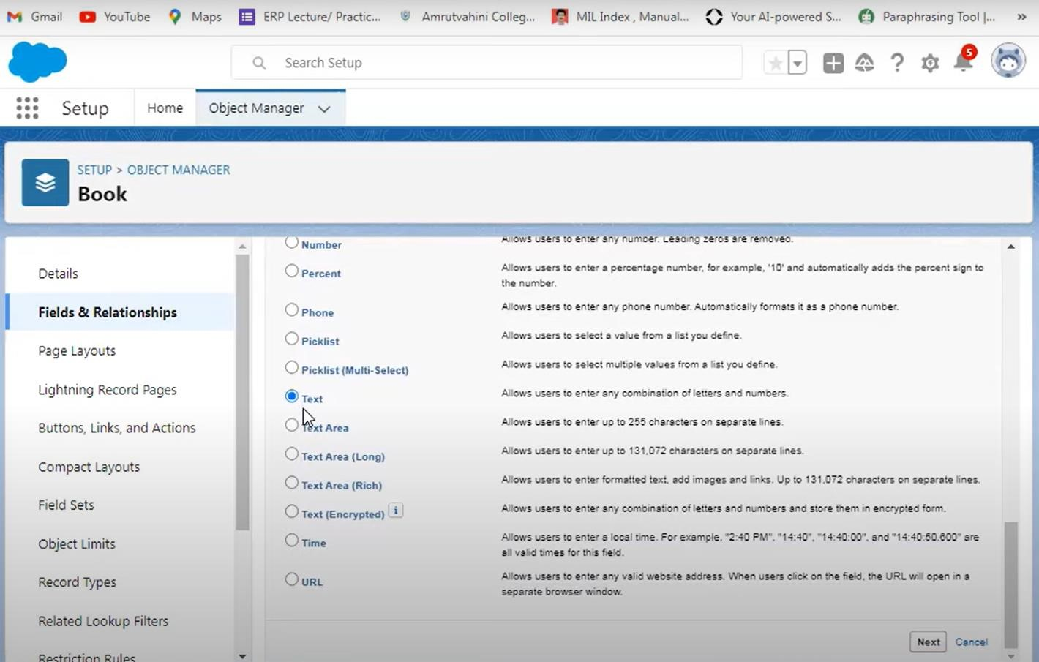

Step 6: Similarly. Repeat steps 4 and 5 to add more fields like Book, and Author. This is how the custom object will have the various fields.

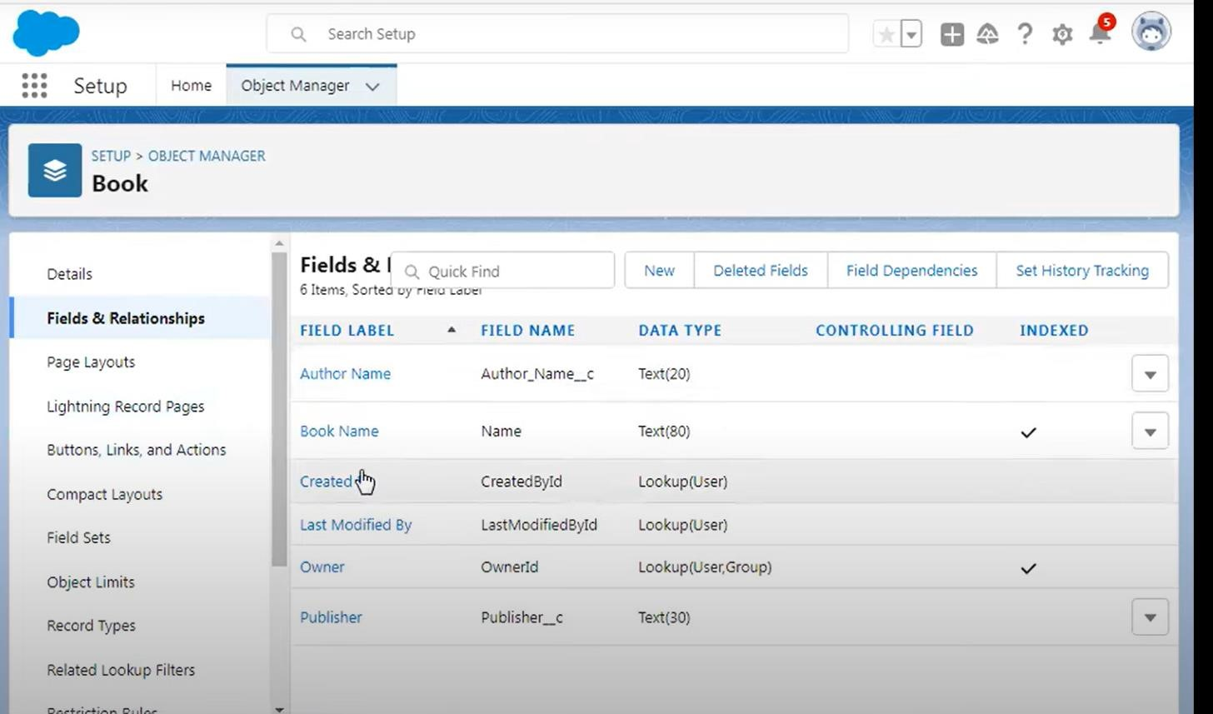

Step 7: Now go to Home => search for “Tabs”. Click on New

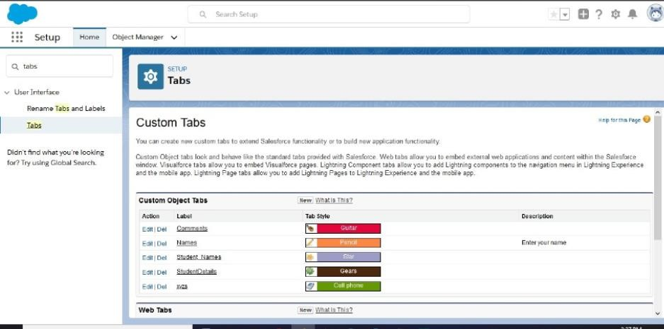

Step 8: Enter the Object name and select any icon for tab style. Leave all defaults as it is. Click Next, Next, and Save.

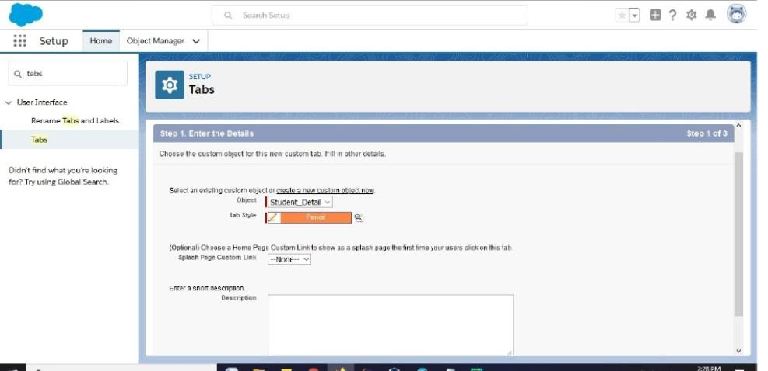

Step 9: In Setup, click Home. Enter “App Manager” in Quick Find and select App Manager. Click New Lightning App

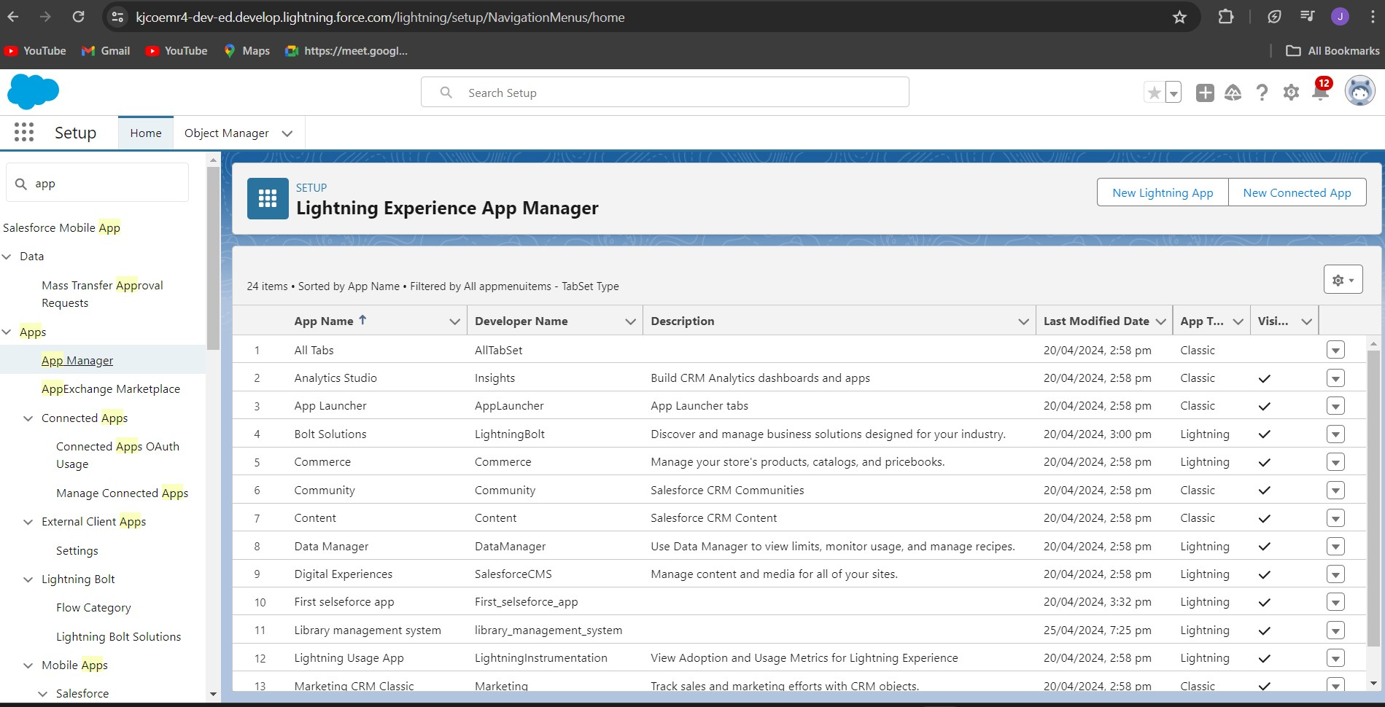

**5.RESULTS AND DISCUSSION**

The custom Sales Force Cloud application project culminates in a transformative solution designed to revolutionize sales operations, enhance efficiency, and foster collaborative synergy. By seamlessly automating lead management, opportunity tracking, and quote generation, coupled with real-time analytics and performance metrics, the application empowers sales teams to navigate complexities with informed precision, propelling revenue growth and fortifying customer relationships. This comprehensive solution, imbued with scalability and flexibility, ensures seamless adaptation to evolving business landscapes. It epitomizes a steadfast commitment to sustained excellence in a rapidly evolving marketplace. Through intuitive user interfaces and centralized data access, the application facilitates seamless collaboration among sales teams, fostering teamwork and synergy. Its modular architecture allows for customizability and integration with existing systems, ensuring alignment with specific business needs and processes. By providing actionable insights into sales trends and customer preferences, the application enables personalized engagement strategies, leading to higher customer satisfaction and loyalty. Its robust security measures safeguard sensitive data, instilling trust and confidence among stakeholders. With ongoing support and maintenance, the application continues to evolve, driving continuous improvement and innovation within the organization.

6. REFERENCE

[1]http://faculty.winthrop.edu/domanm/csci411/Hanouts/ NIST.pdf.

[2] <https://www.salesforce.com/in/what-is-salesforce>

[3]<https://trailhead.salesforce.com/alm_deployment/aim_intro>

[4][https://developer.salesforce.com/docs/atlas.enus.api.res t.meta/api_rest/](https://developer.salesforce.com/docs/atlas.enus.api.res%20t.meta/api_rest/)

1. <https://trailhead.salesforce.com/alm_deployment>
2. Tadepalli Sarada Kiranmayee “A Survey on the Role of Cloud Computing in Social Networking Sites” International Journal of Computer Science and Information Technologies, Vol. 6 (2), 2015, 1509-1512.